Introduction: -

Taxi trajectory data records real-time moving paths sampled as a series of positions associated with vehicle attributes over urban road networks. This data contains abundant knowledge about a city and its citizens. Exploratory visual analytics systems are demanded to study taxi trajectories with efficient user interaction and instant visual feedback.

Project Description: -

In this project, we have implemented a visual analytic system for taxi trajectory data that support data exploration and analytical reasoning with interactive visual interfaces. The system should help the user to conduct visual analytics tasks through an iterative, exploratory process.

The list of 2-level tasks is:

1. Word Cloud
2. Sankey
3. Scatter Matrix

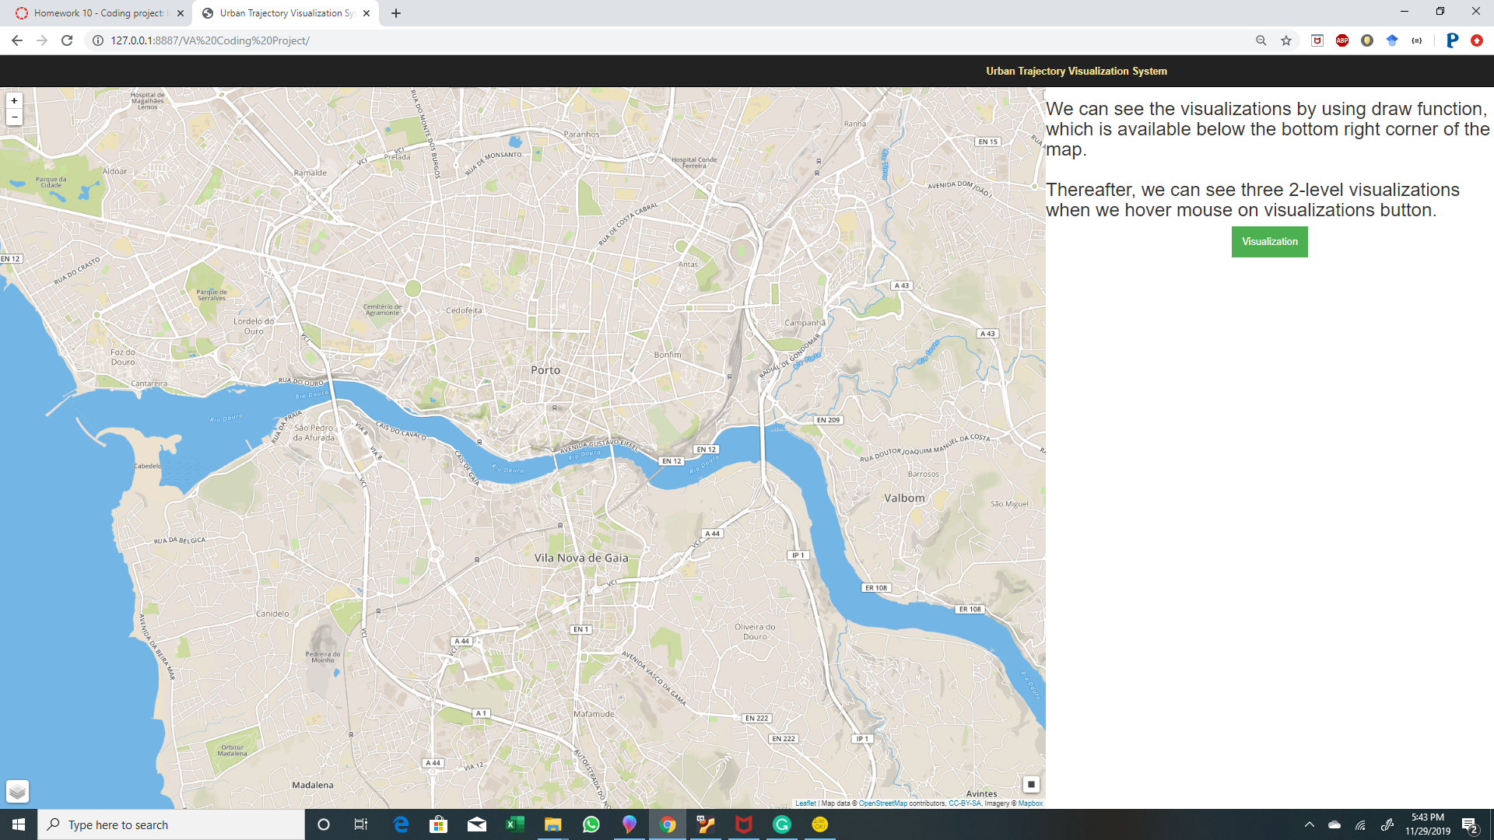

First, we need to install a webserver chrome extension to our google chrome. Then we load our project using this extension. The map interface open and we must select a rectangle which consist of data frames of all the trips within that specific area. To get the visualization we need to hover over visualization button which allows us to choose three 2-level visualizations.

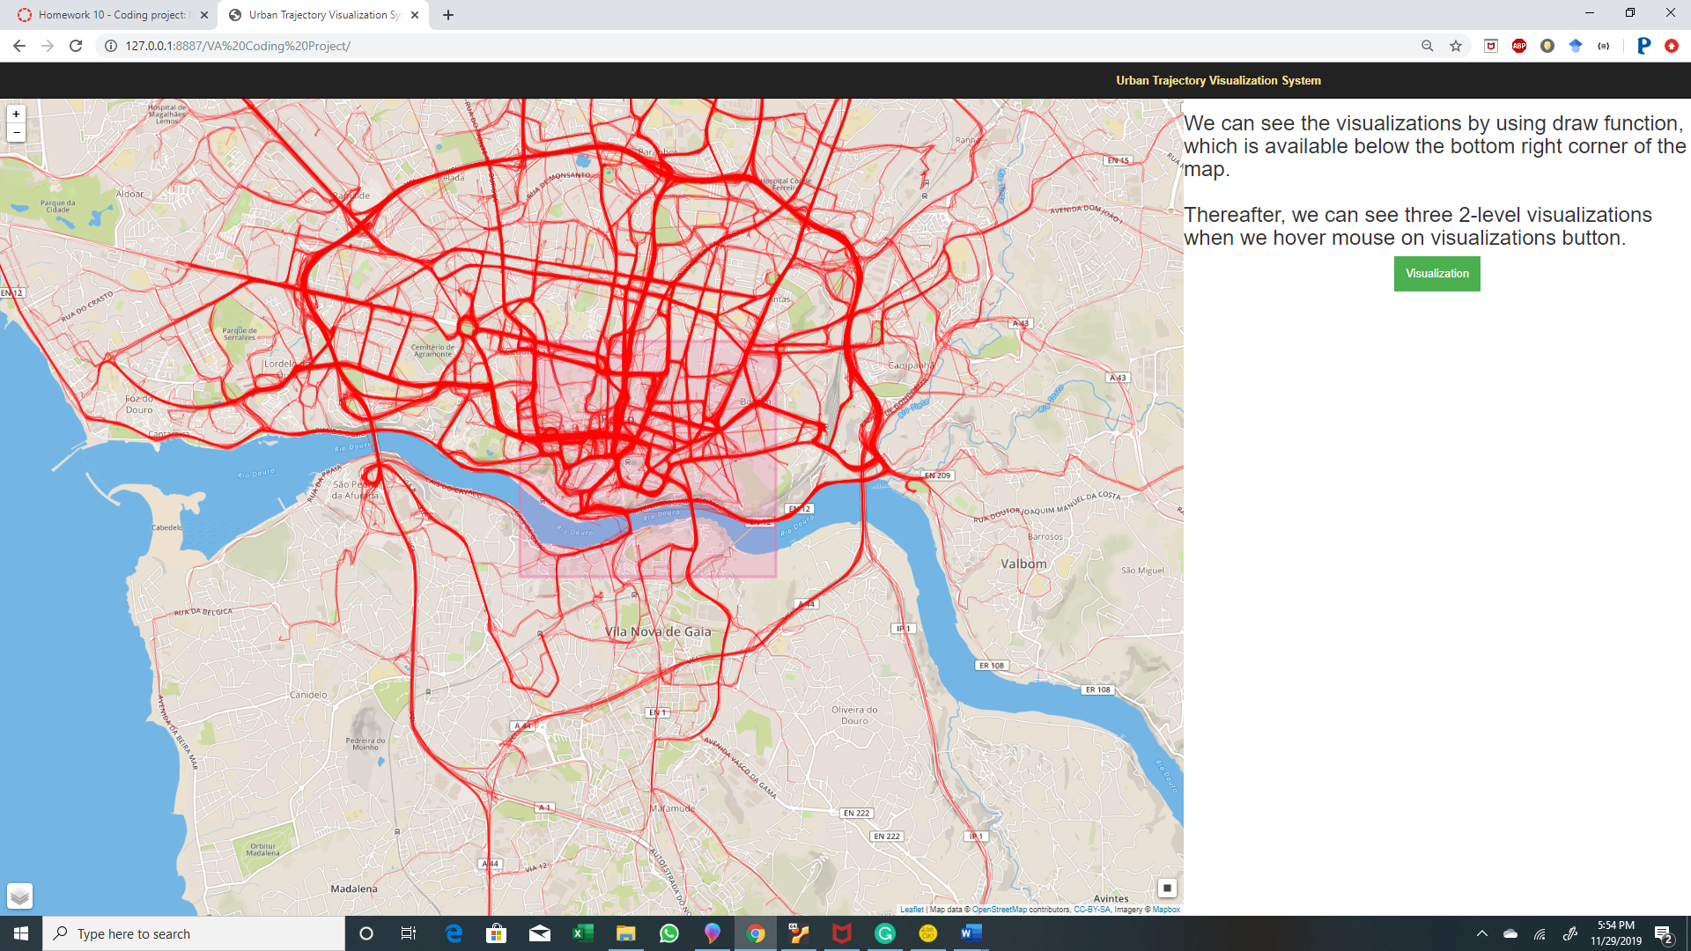

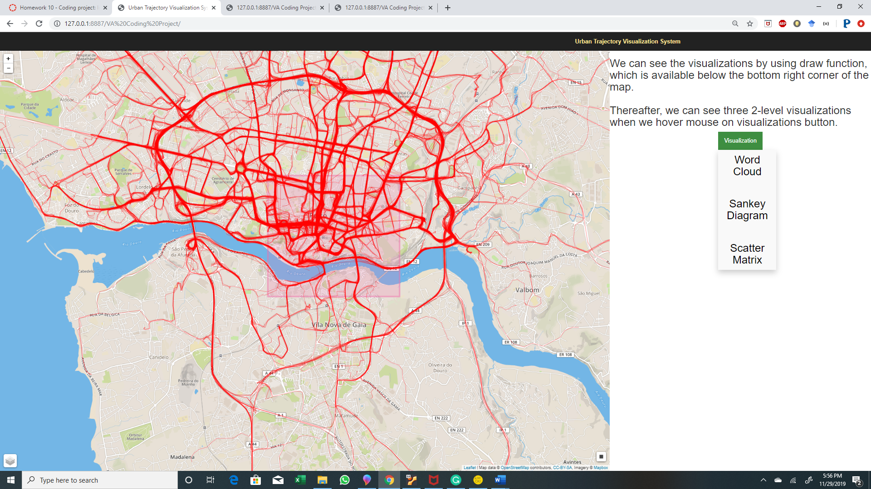

After drawing a rectangle on a map, we can path maps from different streets.

1. WORD CLOUD:

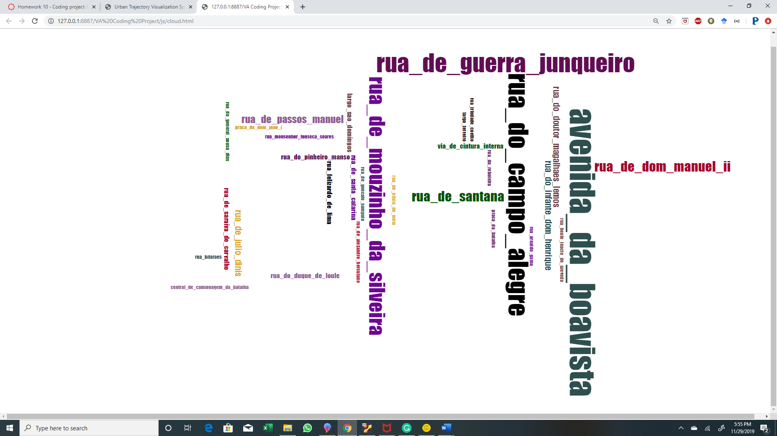

1. SANKEY:

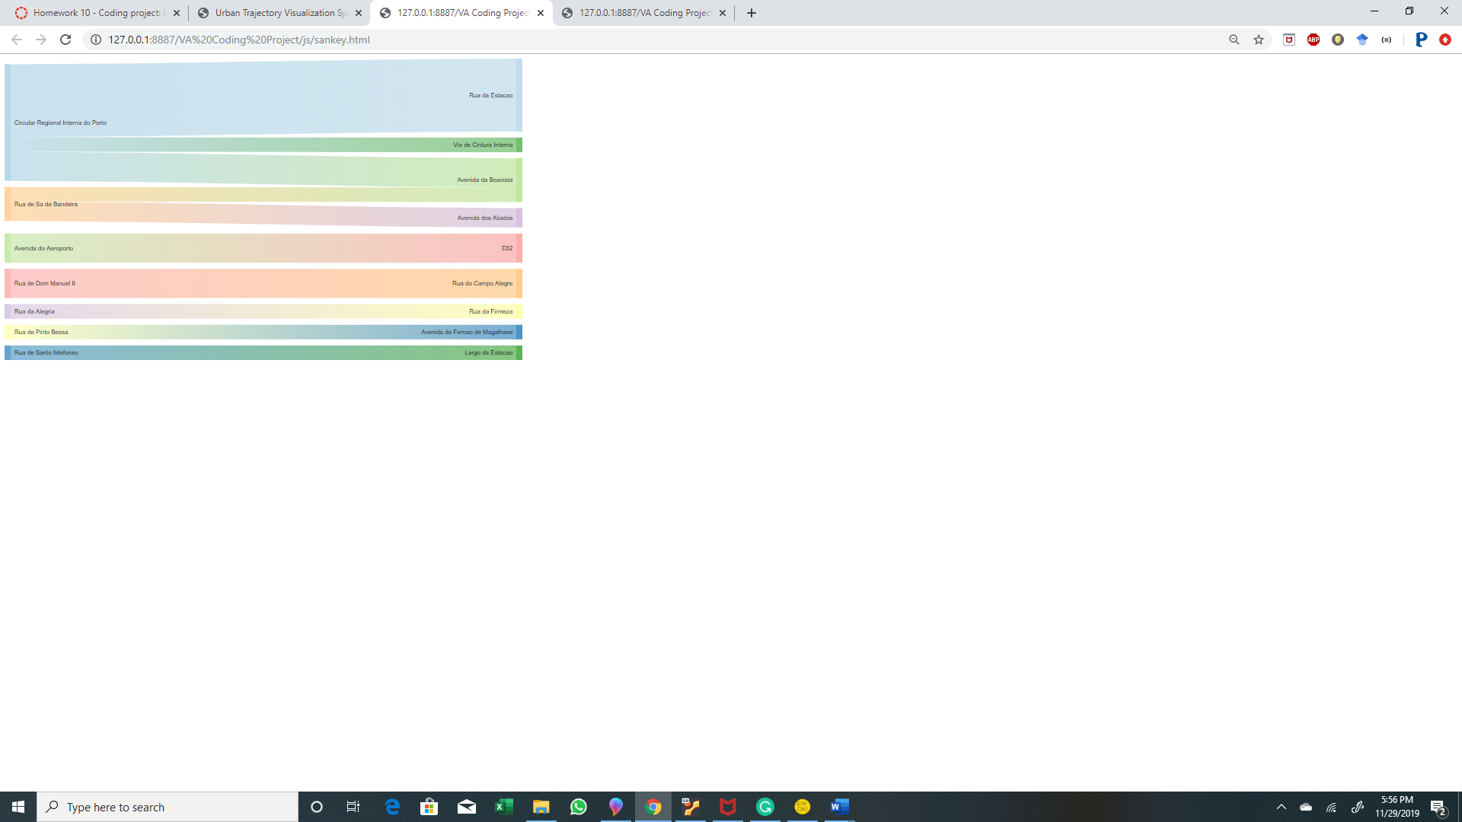

1. SCATTER MATRIX:

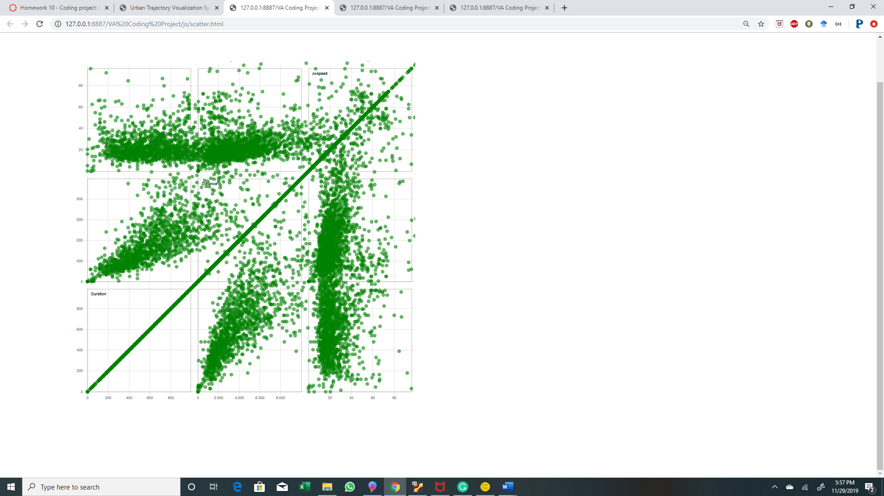

References:

1. <https://developers.google.com/chart/interactive/docs/gallery/sankey>
2. <https://bl.ocks.org/blockspring/847a40e23f68d6d7e8b5>
3. <https://www.jasondavies.com/wordcloud/>
4. <https://blockbuilder.org/bricedev/8b2da06ddef27d94cde9>
5. <https://observablehq.com/@d3/brushable-scatterplot-matrix>